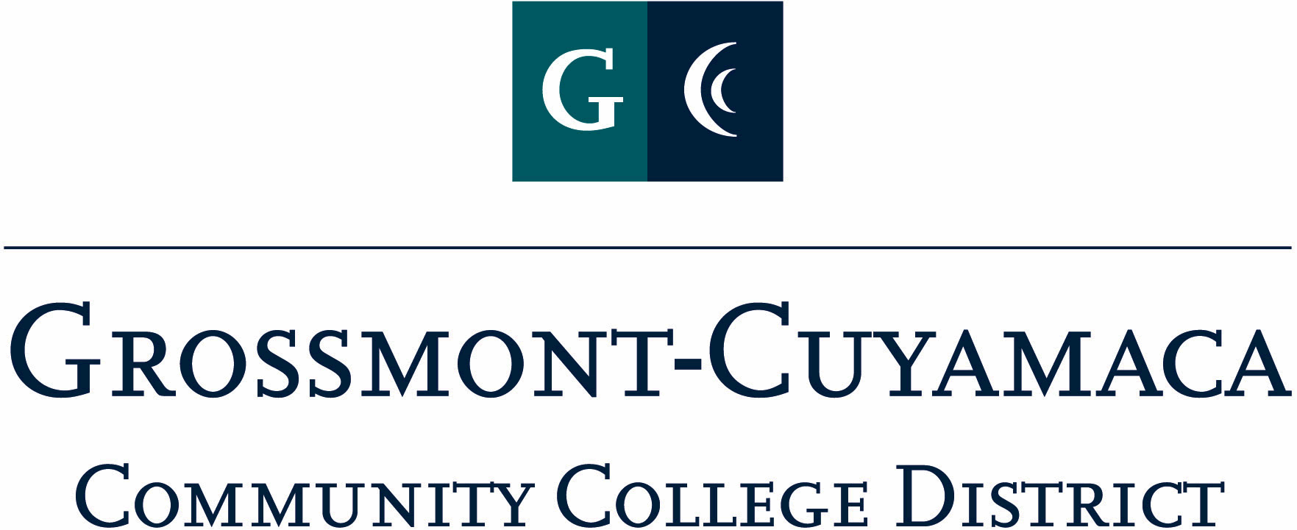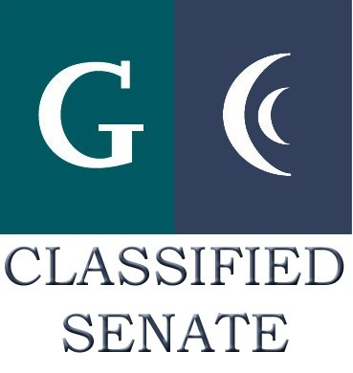
CLASSIFIED SENATE
EXECUTIVE BOARD MEETING
February 1, 2011– Meeting Minutes

Members Present: Joe Balistreri, Maria Briney, Wendy Corbin, Lynne Davidson, Scott Howell,
Debi Miller, Avelina Mitchell, Pat Murray, Karen McCoy, JacQ Osborne, Rocky Rose, Paula Tillery
Members Absent: Patricia Bailey, Monica Farris, Maggie Gonzales
Members Excused: Angela Johnson, Yvette Macy, Jean Wallace

1. Welcome and Call to Order
The meeting was called to order at 12:08p. The president asked for items to be added to the agenda.

2. Approval of Minutes from 11/2/10
The minutes from the December 7, 2010 meeting were approved as submitted.
M/S/A Rose/Mitchell. Motion passed.

3. Continuing Business
CSAD
Facilities: Maria Briney reported she would like to meet with Bruce Farnham, Cuyamaca Director of Facilities and will send an e-mail to him.

Food: Avelina Mitchell reported there will be a buffet style breakfast and lunch and a Las Vegas theme. She will be meeting with Sodexo this week.

Workshop & Entertainment: Wendy Corbin asked for suggestions on the best way to solicit volunteers. She asked for help organizing. She spoke with people in District Purchasing and Accounting on the problems they get the most calls on. President Miller stated the schedule and time for workshops has been determined. Wendy Corbin and Maggie Gonzales will meet about the letter template to be sent out district-wide. The next step is to ask for feedback from district people, ask for input by a certain date, and call the people who do not respond to ask about the recurring workshops. She agreed to help.

Public Relations, Raffle/Donations, and Fiscal Coordination: President Miller reported these items were tabled until next the meeting.

4. Communication
VP Reports

Cuyamaca Report:
President Miller reported Maggie Gonzales is ill today and will report next month.

Grossmont Report:
Pat Murray reported on CSAD workshops and working to send out follow-up communication on the staff development survey. She also reported that Grossmont College had a good convocation. Due to a death in Dr. Cooke’s family, Dr. Colson did the staff development workshop for classified.

District Report:
Wendy Corbin reported working on getting the shared governance process started, and asked for more male participation on committees. The PB&J feedback from the classified representatives will be looking at the District Office reorganization, issues with Risk Management disappearing, and reassignments led by Chancellor Miles. President Miller reported concern there are no Human Resources rep at Chancellor’s Cabinet.

President’s Report: President Miller reported there would be an Accreditation visit by Dr. Nixon February 9.

CLI Scholarship (Review Committee): President Miller reported Pat Murray and Avelina Mitchell were the recipients of the scholarship award. Pat Murray shared that Dr. Cooke had agreed to pay for her to attend CLI, so the next recipient on the list is Karen McCoy. Karen will let the President know if she able to attend, if not the scholarship will then be awarded to Joe Balistreri. The District Office will fund Wendy Corbin at CLI. President Miller will fund herself. She asked the representatives to request their supervisor’s approval and to complete the appropriate off campus forms. She congratulated everyone on this big honor. Avelina Mitchell agreed to be the alternate on the delegate form for CLI.

Annual Organization Meeting: President Miller reported the meeting will be March 24. She distributed the election Nomination Form based on the last election and asked members to review as the first read. Paula Tillery and Lynne Davidson agreed to oversee the election and receive the nominations and tabulate the votes.

CSAD Keynote: President Miller reported she will meet with Pat Murray, Wendy Corbin and Dr. Funshine, the comic keynote speaker who does laughter yoga. The cost is $500.

4/10 Summer Schedule: President Miller reported the district would repeat the 4/10 Summer Schedule this year, the Classified Senate Retreat will be on 9/23 and she will secure that date through Mission Trails.

Treasurer Report: Paula Tillery reported on the distributed January 31, 2011 Treasurer Report which showed the expenses and profits. The See’s Candy profit was $386. The cookbook sales had the best profit. There was a $4,506.59 fund balance.

5. Fundraising Activities:

See’s Candy (spring): President Miller reported for Yvette Macy and stated the See’s Candy fundraiser is a lot of work with less profit than fall. Members discussed the value of continuing the spring sale, and what would replace the income if discontinued. President Miller agreed to report on the See’s spring profit and bring back to the next meeting. Lynne Davidson agreed to work with Yvette Macy on this fundraiser.

BBQ Update: There was no report this month.
Spring 2011 Fundraiser Ideas: See See’s Candy (spring) above.

6. Governance:

Classified Professional Development Committee: There was no report this month.

Classified Staffing Review Committee: Wendy Corbin reported the committee is working to update the internal process and to develop a format guide to prioritize districtwide hiring staffing needs.
The Screening Committee Internal Process was presented to the group for a 1st read. Please submit any feedback to the President.
7. New Business: No report.

8. Other: Lynne Davidson asked about feedback on the Classified Staff Development Survey. President Miller explained some requested changes were not reflected in the final survey sent out. Lynne Davidson agreed to talk to Yvonne Reid- Hairston for clarification.

DCEC is looking for a Grossmont and Cuyamaca classified rep to be on the Education master Plan Committee for each college. Karen Ostegard has agreed to participate for Grossmont College, and Debi Miller will work with Maggie Gonzales on securing a rep from Cuyamaca College.

The next meeting will be March 1, 2011. The meeting adjourned at 12:59p.

